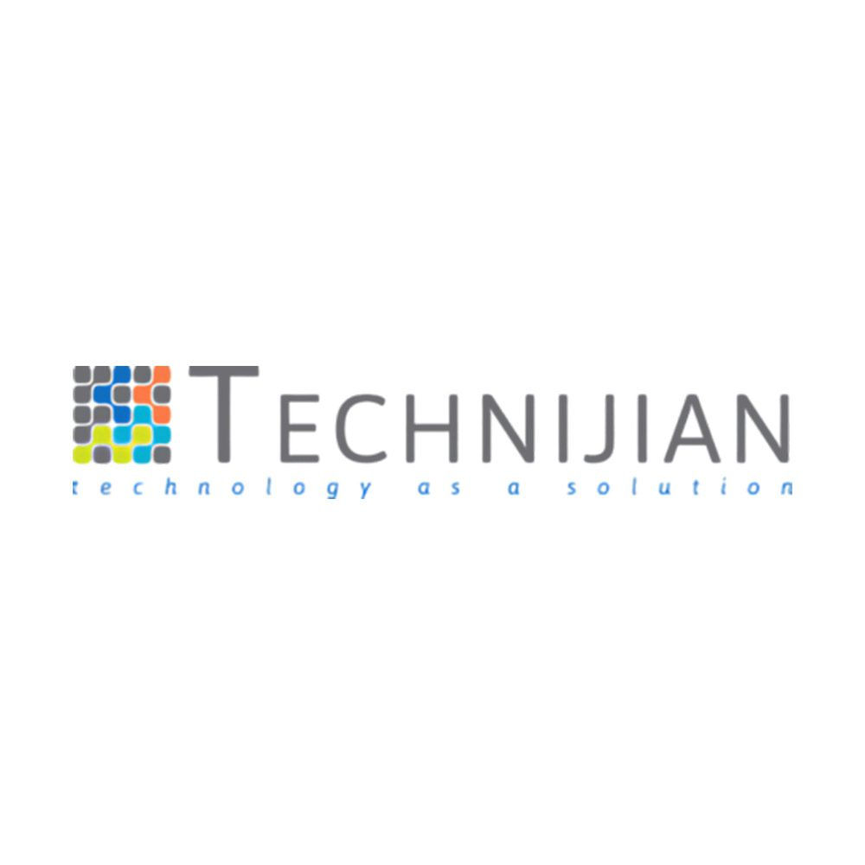
ENTERPRISE AI PLATFORM
Technijian Chat.AI
Collective Intelligence for the Modern Enterprise
────────────
Multi-Model AI • Workflow Automation • Enterprise Governance

The Challenge with Enterprise AI Today
Organizations face real barriers adopting AI at scale. These four challenges prevent teams from realizing the full potential of artificial intelligence.
Single-Vendor Lock-In
Tying your organization to one AI provider means you inherit their outages, pricing changes, and model limitations.
→ Chat.AI orchestrates OpenAI, Anthropic, Google, and Azure simultaneously with automatic failover.
No Cost Visibility
ChatGPT Team and Copilot charge flat per-seat fees with no transparency into actual token consumption or model costs.
→ Per-call cost attribution, prepaid budgets, and overage alerts give you complete financial control.
Hallucinations & Unreliable Output
Single-model responses have no checks or balances. Users can't tell when the AI is confidently wrong.
→ AI Council deliberation across 3+ models reduces hallucinations by over 30% with consensus validation.
Security & Compliance Gaps
Consumer AI tools lack tenant isolation, audit trails, and the controls required for regulated industries.
→ Row-level security, stored-procedure-only data access, full audit logging, and HIPAA/SOC 2 architecture.

Platform Capabilities
Everything your organization needs to adopt AI securely and effectively.
⚙ Multi-Model Chat
Conversational AI powered by GPT-4o, Claude Sonnet, Gemini Pro, and more.
- Switch models mid-conversation or let the platform route automatically
- Streaming responses with file attachments & analysis
- Thread sharing with permissions, export & history

★ Custom AI Assistants
Create purpose-built AI assistants with custom system instructions.
- Per-assistant model selection and connector integrations
- REST, GraphQL, and database connectors attachable to assistants
- Shared or private assistants, MyGPTs for personal productivity

📂 Projects & Workspaces
Organize chats, files, and instructions into project containers.
- Project-level system prompts inherited across all chats
- Shared files & organizational knowledge base
- Granular view/edit permissions with cross-chat context

⚡ Workflow Automation
Trigger N8N workflows directly from chat context.
- Chat-initiated workflow triggers with parameter extraction
- Multi-step business process execution from conversation
- Run tracking, retry mechanisms, and cost attribution per workflow

📈 Knowledge & Memory
Upload documents and give AI persistent organizational memory.
- Weaviate, Pinecone, or Chroma vector stores per tenant
- File vectorization, embedding, and semantic search
- Retrieval-augmented generation (RAG) capabilities

💰 Billing & Cost Controls
Prepaid balance model with token-level metering.
- Per-call, per-user, and per-model cost attribution
- Budget alerts at 75% and 100% thresholds
- Invoice generation and billing period management

PATENT PENDING
AI Council — Collective Intelligence
The industry's first multi-agent deliberation system. Instead of trusting a single AI model's opinion, Chat.AI convenes a council of 3+ diverse models through a structured 3-stage pipeline — delivering answers that are more accurate, more balanced, and dramatically less prone to hallucination.
1. Divergence
Your query is routed to 3+ AI models in parallel. Each model responds independently with no knowledge of the others.
2. Convergence
Responses are anonymized (model names stripped to prevent sycophancy) and peer-reviewed for semantic similarity, with mandatory dissent encouraged.
3. Synthesis
The highest-performing model (auto-selected chairman) synthesizes a consensus response using Bayesian weighting and correlation analysis.
>60%  Win Rate vs  Single Models | >30%  Hallucination  Reduction | 3+  Models Per  Deliberation | 100%  Anonymized  Peer Review

Supported: GPT-4o • Claude Sonnet • Gemini Pro • GPT-4o mini • Claude Haiku • Gemini Flash • Claude Opus • Azure OpenAI

Who Uses Chat.AI
Organizations across industries trust Chat.AI for secure, intelligent AI adoption.
Legal Firm • 25 Users
Challenge: Needed multi-model AI for contract review with strict audit compliance requirements.
Solution: AI Council consensus reduced review errors by 40%. Full audit trail satisfies compliance auditors. Multiple model perspectives catch contract risks a single model misses.
Result: 40% Reduction in Review Errors
Healthcare Provider • 100 Users
Challenge: Required HIPAA-compliant AI for clinical Q&A without sending patient data to third-party clouds.
Solution: On-premise deployment with row-level security keeps data in-house. Cost controls prevented budget overruns. Clinical staff access AI without compliance risk.
Result: $0 Compliance Violations
Financial Services • 500 Users
Challenge: Was paying for 5 separate AI tools, workflow platforms, and vector databases with no unified cost visibility.
Solution: Consolidated to single platform with Chat.AI Enterprise. Token-level metering replaced guesswork. 50% fewer vendor contracts to manage.
Result: $174K Annual Savings

Simple, Transparent Pricing
No hidden fees. No per-seat surprises. Annual plans save 17%.
 | Starter | Growth | Professional ★ | Enterprise
Monthly Price | $299 | $899 | $1,699 | Custom (from $3,999)
Annual Price | $2,990 | $8,990 | $16,990 | Custom
Users | 10 | 50 | 100 | 250 – 1,000+
Tokens/month | 10M | 35M | 75M | 200M – 750M+
Storage | 10 GB | 50 GB | 150 GB | 500 GB – 2 TB
Custom Assistants | 5 | 25 | Unlimited | Unlimited
Workflows | 10 | 50 | Unlimited | Unlimited
AI Council | — | — | ✓ Included | ✓ Included
Model Tier | Standard | Pro | Pro + Premium | All Premium
Uptime SLA | 99.0% | 99.5% | 99.5% | 99.9 – 99.95%
Support Response | 72 hours | 48 hours | 24 hours | 4 – 1 hour
Token Overage | $16/1M | $15/1M | $14.75/1M | $14.50/1M

Deployment Options
☁ Cloud (SaaS)  Fully managed on Azure with automatic updates, monitoring, and 24/7 global support.  Starting at $299/mo | 🏠 On-Premise  Deploy inside your own infrastructure for maximum data sovereignty.  Starting at $45,000/yr

How Chat.AI Compares
Capability | ChatGPT Team | MS Copilot | Gemini Business | Chat.AI
Multi-model access | OpenAI only | OpenAI only | Google only | ✓ 4+ providers
AI Council (consensus) | — | — | — | ✓ Patent pending
Per-call cost attribution | — | — | — | ✓ Token-level
Workflow automation | GPTs only | Power Automate ($) | — | ✓ N8N built-in
Multi-tenant isolation | — | Basic | Basic | ✓ Row-level security
Full audit logging | — | Limited | Limited | ✓ SP-enforced
Custom vector stores | OpenAI only | — | — | ✓ Weaviate/Pinecone/Chroma
On-premise deployment | — | — | — | ✓ Term license
Budget controls | — | — | — | ✓ 75%/100% alerts
Price (25 users) | $625/mo | $750/mo | $500/mo | $899/mo (50 seats)

What You Save
Real cost comparisons for typical organizations switching to Chat.AI.
Scenario | Current Cost | Chat.AI | Monthly Savings | Annual Savings
Small Team (10) | $389/mo | $299/mo | $90/mo | $1,080
Mid-Market (50) | $2,500/mo | $899/mo | $1,601/mo | $19,212
Enterprise (250) | $18,500/mo | $3,999/mo | $14,501/mo | $174,012

Enterprise-Grade Security & Compliance
🔒 Azure AD SSO — OAuth 2.0/OIDC with JWT bearer tokens
🛡 Row-Level Security — Database-enforced tenant isolation
📄 Full Audit Trail — Every mutation logged with user & timestamp
🔐 Azure Key Vault — All secrets encrypted at rest
⚠ Prompt Injection Defense — Salted sequence tags & delimiter separation
🏣 HIPAA / SOC 2 Ready — Compliance-ready architecture
🛠 RBAC Roles — Multi-level role hierarchies
🚀 Rate Limiting — Per-user, per-tenant throttling

About Technijian
Founded in 2000 by Ravi Jain, Technijian has grown from a single-consultant operation into a full-spectrum IT services company with offices in Irvine, California and India. For over 25 years, we've served small and mid-sized businesses with managed IT, cybersecurity, cloud, compliance, and AI-driven solutions.
Our Technijians Pod Model assigns a dedicated team to each client — so you get people who truly know your infrastructure, not a rotating cast of strangers. With 24/7 global support at no extra cost, we deliver enterprise-grade technology with the responsiveness of a dedicated partner.
25+  Years in Business | 24/7  Global Support | 6  Service Pillars

Ready to Transform How Your Team Uses AI?
Schedule a personalized demo and see how Chat.AI delivers better answers
at a lower cost than any single-model solution.
RJain@technijian.com • 949.379.8500

© 2026 Technijian • 18 Technology Dr. Ste 141, Irvine CA 92618 • technijian.com

